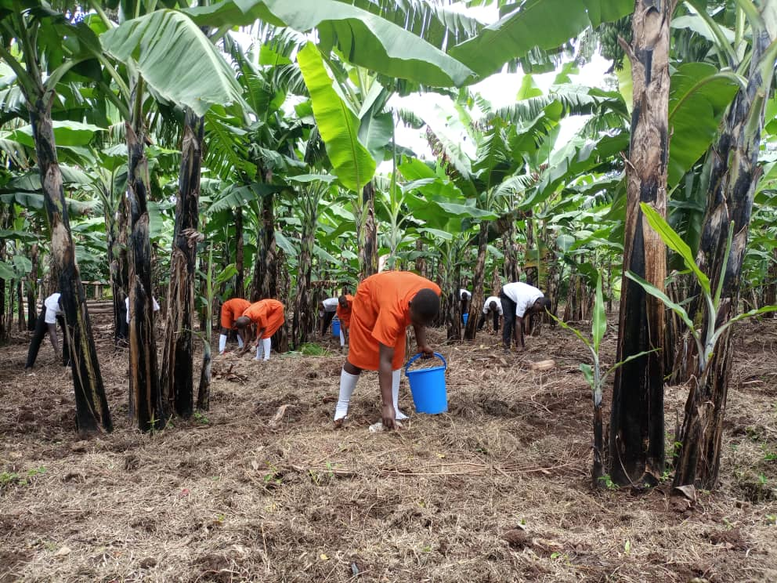
AGRICULTURE PROJECT

PROJECT STUDENTS REMOVING NON-BIODEGRADABLES FROM SCHOOL PLANTATION

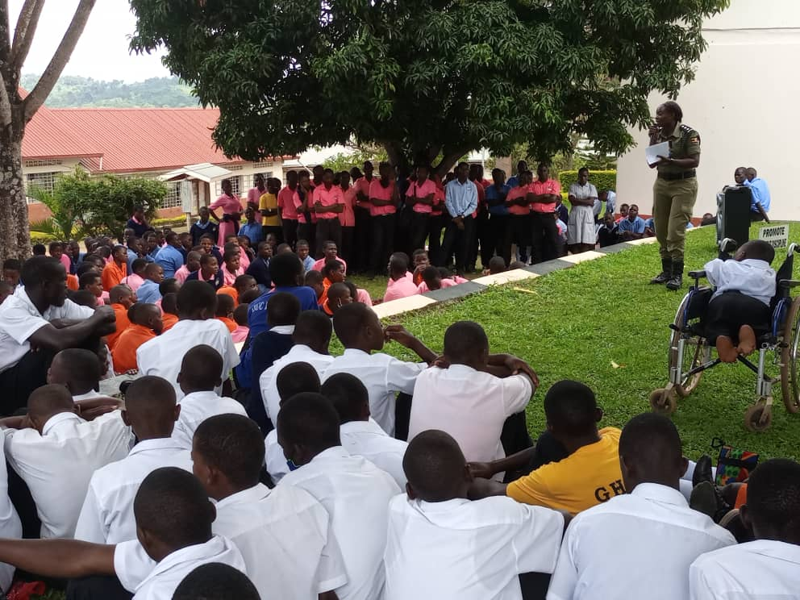
HUMAN RIGHTS

STUDENTS SHARING WITH POLICE OFFICERS ON HUMAN RIGHTS

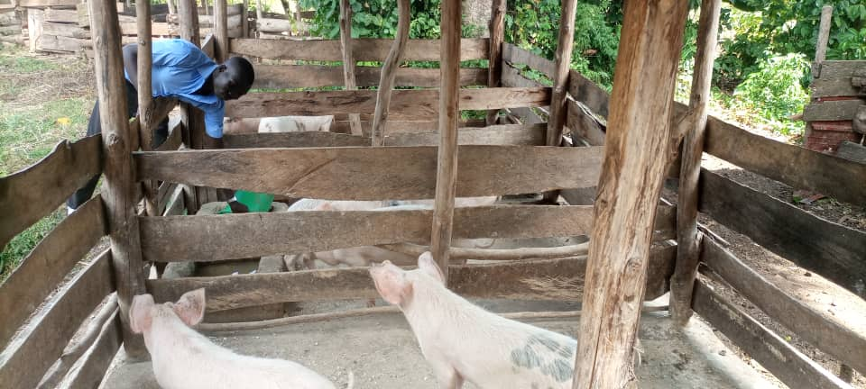
AGRICULTURE PROJECT

S.3 AGRICULTURE STUDENT FEEDING PROJECT ANIMALS

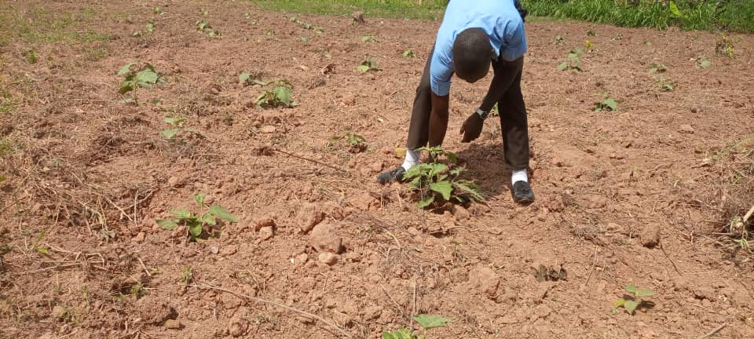
AGRICULTURE PROJECT

EGG PLANT PROJECT PLOT

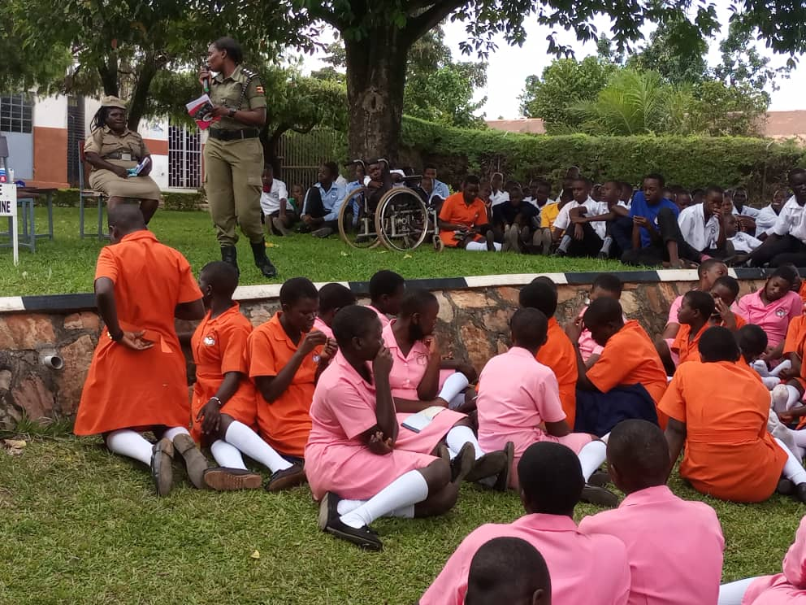
HUMAN RIGHTS

STUDENTS SHARING WITH POLICE OFFICERS ON HUMAN RIGHTS

AGRICULTURE PROJECT
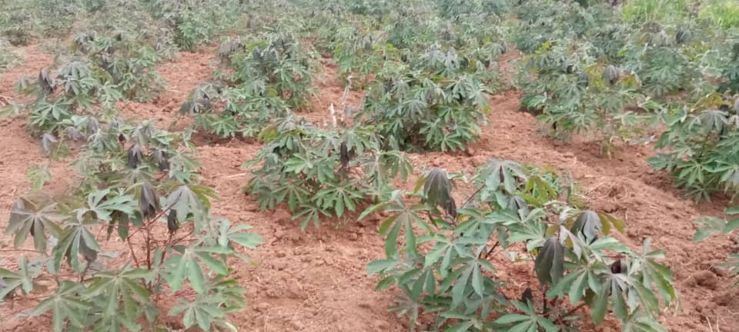

CASSAVA GARDEN PLOT

SANINATION/S. O. P’S
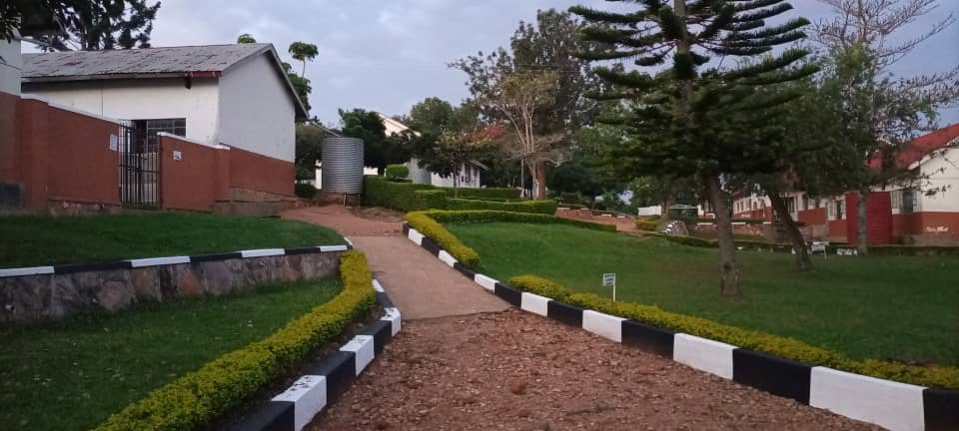
GIRLS’ WING

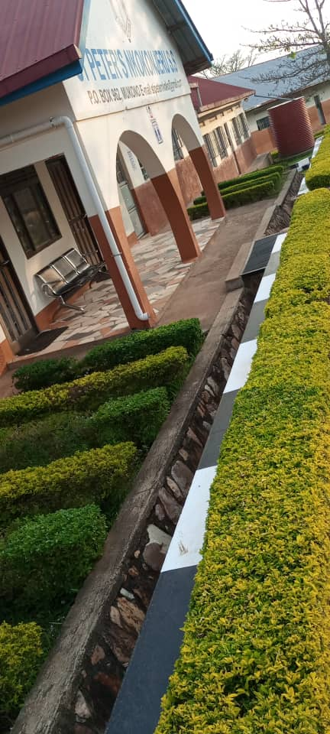
SANINATION/S. O. P’S

SCHOOL FRONT VIEW

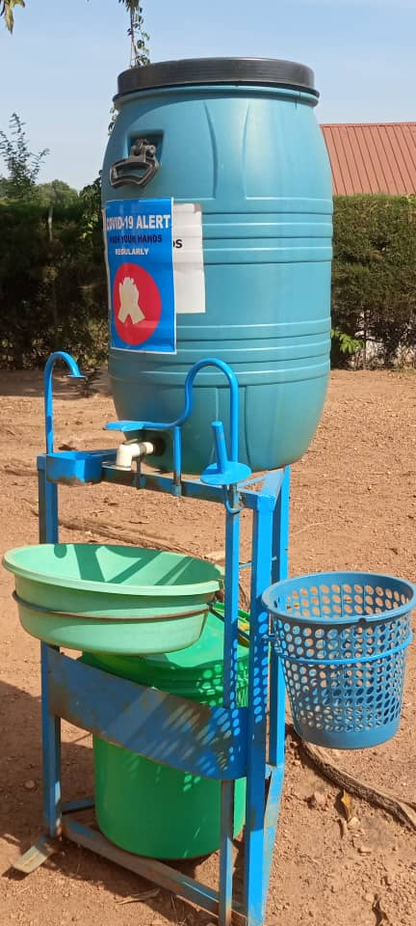
SANINATION/S. O. P’S

FOOT OPERATED HAND WASHING MACHINE AT THE SCHOOL ENTRY

